Checks and Questions XChange Box

Questions
- What is the Hardware ID of your XChange box?
- What is not working? A detailed description of the problem needs to be done (Screenshots will be helpful)
- Tests to perform:
  - Ensure that both cables (data and voice) are well inserted.
  - Try to turn the device off and on again from the WebInterface of the XChange box.
  - Try to switch off the XChange box and switch it on again. Did this action solve the problem?
  - Try to switch off the terminal(s) used with the XChange box and switch it on again. Did this action solve the problem?
  - If this action changed the behavior or message, describe these changes in detail.
  - Was the box started correctly (can be tested by the captain when logging in the box)?
    - If no, ask someone to plug a screen on the XChange box and provide the error message.
  - In case the VSAT is not recognized by the box, confirm that the VSAT is plugged on the WAN2 of the box and on the correct port of the HP modem.

Checks
- Please remind that the box is a service so it’s working with a product which needs to be checked.
- Check Portal 360 for the status/logs/sync/version of the box.
- Refer to the photos below for the cable set up.
- Box1
- Box2
- Box3
- Box4

- Box1
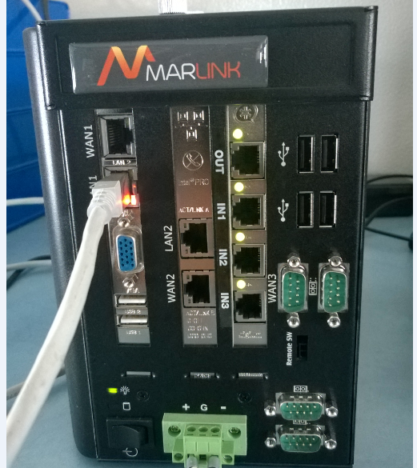

Back to Top

- Box2
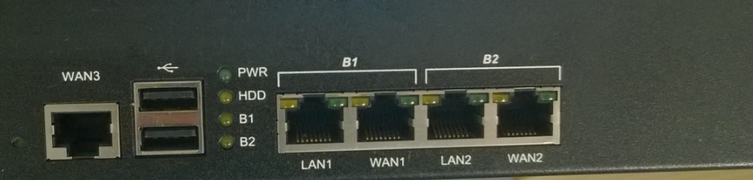
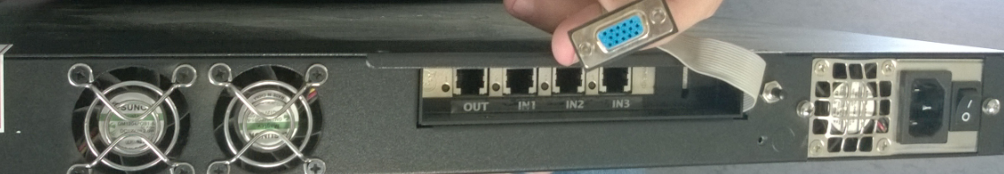

Back to Top

- Box3
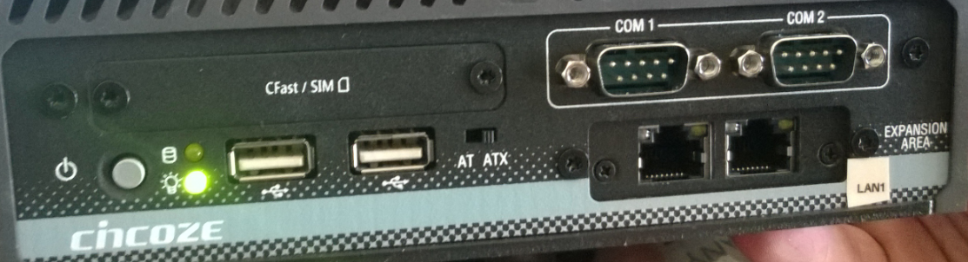
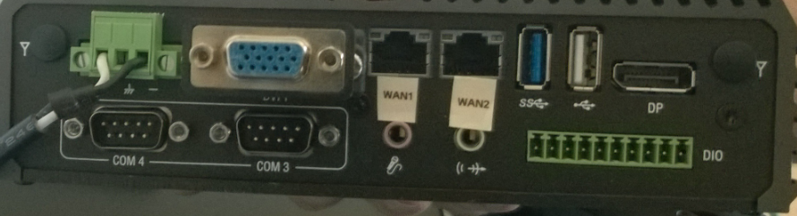

Back to Top

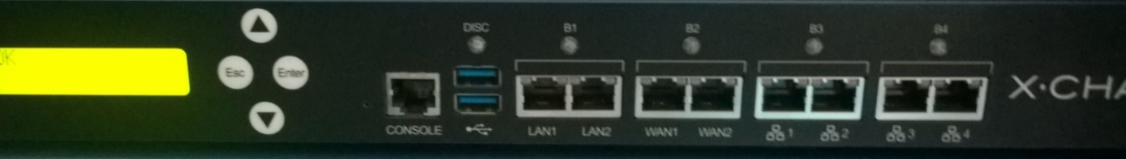
- Box4

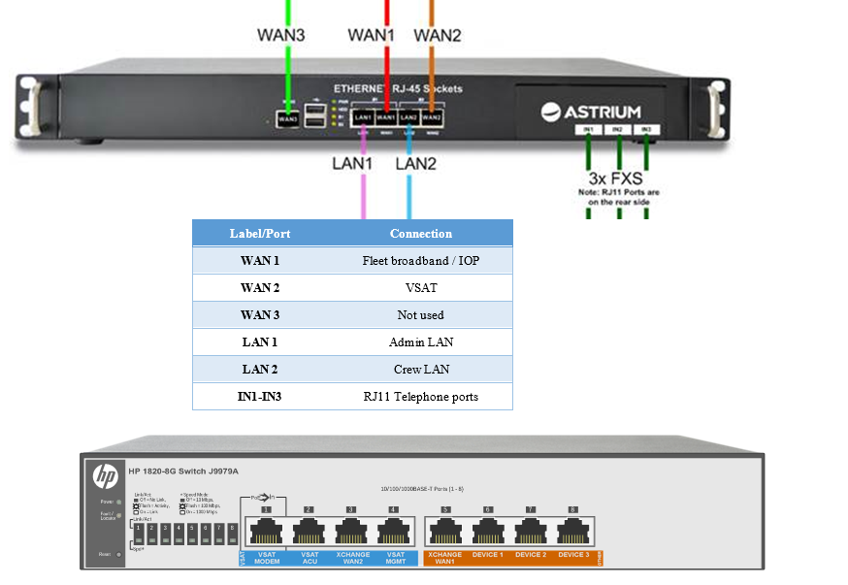
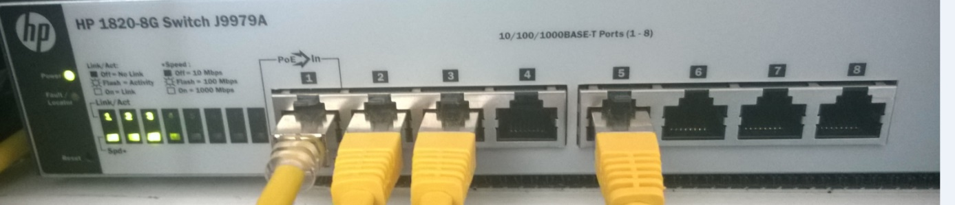
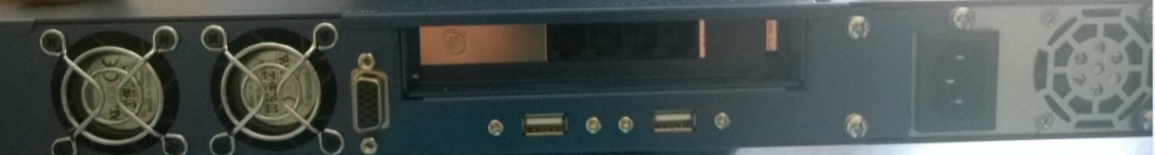

Back to Top

